

BOARD OF TECHNICAL EDUCATION, BANGLORE

Department of Computer Science & Engineering

SIMULATION OF CLOUD COMPUTING ECO-EFFICIENT DATA
CENTER

Project Report submitted in partial fulfilment of the requirement for the Award of Diploma in 6th Semester

Computer Science & Engineering

By the Technical Education Board Bangalore.

SUBMITED BY

Mr. Suhelahamed Kuntoji Ms. Saniya Agha

Mr. Prajwal Bagewadi Mr. Tushar Metri

Mr. Ganesh Patil

UNDER THE GUIDENCE OF

Mr. Bushan Aptekar



BOARD OF TECHNICAL EDUCATION, BANGLORE

Certificate

Mr. Suhelahamed Kuntoji Ms. Saniya Aga

Mr. Prajwal Bagewadi Mr. Tushar Metri

Mr. Ganesh Patil

This is to certify

Batch-I

Has satisfactorily completed the project work entitled

SIMULATION OF CLOUD COMPUTING ECO-EFFICIENT DATA CENTER

For the partial fulfilment of Award of Diploma in Computer Science & Engineering by the Department of Technical Education Board, Bangalore During academic near 2017-2018

Guide Head of Department Principal

Mr.Bhushan Aptekar Mr.Sandeep Patil Shri. A. M. Potdar

Examiner

1. 2

INDEX

 | SL NO |  | CONTENTS |  | PAGE NO
 | 1 | Introduction |  |  | 1-3
 | 2 | Literature Survey |  |  | 4-6
 |  | Problem Definition & Requirement
 |  | Specification
 | 3 | 3.1 | Existing System |  | 7-9
 |  | 3.2 | Proposed System
 | 4 | Implementation
 |  | 4.1 | Implementation Details
 |  | 4.2 | Experimental Results and Discussion |  | 12-24
4.3 System Architecture
4.4 Data Flow Diagram
4.5 Design
4.6 Software Development Methods
4.7 Modeling
4.8 Structure Diagrams
4.9 Use Case Diagram
4.10 Hardware & Software Specifications

5 | 5. Technical Specification  5.1 Introduction to Java  5.1.1Java Identifiers  5.1.2 Java Modifiers  5.1.3 Java Variables  5.1.4 Java Swings  5.2 Introduction to Netbeans IDE  5.2.1 Netbeans IDE Release  5.2.2 Netbeans Platform  5.3 Introduction to Cloudsim  5.3.1 Introduction  5.3.2 Cloud Deployment Model  5.3.3 What is Cloudsim?  5.3.4 Main Features  5.3.5 Applications of Cloudsim  5.3.6 Cloud Services  5.3.7 Cloudsim In Social Networking  5.4 Introduction to Wamp  5.4.1 What is Wamp?  5.4.2 What is Wamp used for?  5.4.3 What are the Advantages of WampServer?  5.5 Introduction to Xampp  5.5.1 Features  5.5.2 Usage  5.5.3 Installation Considerations  5.5.4 What’s included in Xampp? |  | 25-43
6 | 6. Coding  6.1 HeristicOptOnDemandCmplx.java  6.2 HeristicOptOnDemandReservBasedMdl_1.java |  | 44-53
7 | 7. TESTING  7.1 Introduction  7.2 Unit Testing  7.3 Performance Testing  7.4 Integration Testing  7.5 Acceptance Testing  7.6 Validation Testing  7.7 Output Testing  7.8 Functional Testing  7.9 System Testing  7.10 White Box Testing  7.11 Black Box Testing  7.12 Spiral model  7.13 Type of Testing in Cloud  7.14 Test Cases for Cloud Testing |  | 56-62
8 | 8. SNAPSHOTS  8.1 Coding View On-Demand  8.2 Coding View Reservation  8.3 Heuristic run  8.4 Resource Utilization Cost On a Graph  8.5 Result 1 In WampServer  8.6 Result 2 In WampServer |  | 64-69
9 | 9. RESULT ANAYLSIS |  | 71-73
10 | 10. CONCLUSION |  | 74
11 | 11.REFRENCES | 75

LIST OF FIGURES

Figure No | Figure Name | Page No
Fig 4.3 | System Architecture | 16
Fig 4.4 | Data flow diagram | 19
Fig 4.8.3 | UML Diagram | 24
Fig 4.9 | Use Case Diagram | 24
Fig 7.12 | Spiral Model | 60

LIST OF SNAPSHOTS

Figure no | Figure name | Page No
Fig 8.1 | Coding View On-Demand | 65
Fig 8.2 | Coding View Reservation | 66
Fig 8.3 | Heuristic run | 67
Fig 8.4 | Resource Utilization Cost On a Graph | 68
Fig 8.5 | Result 1 In WampServer | 69
Fig 8.6 | Result 2 In WampServer | 70

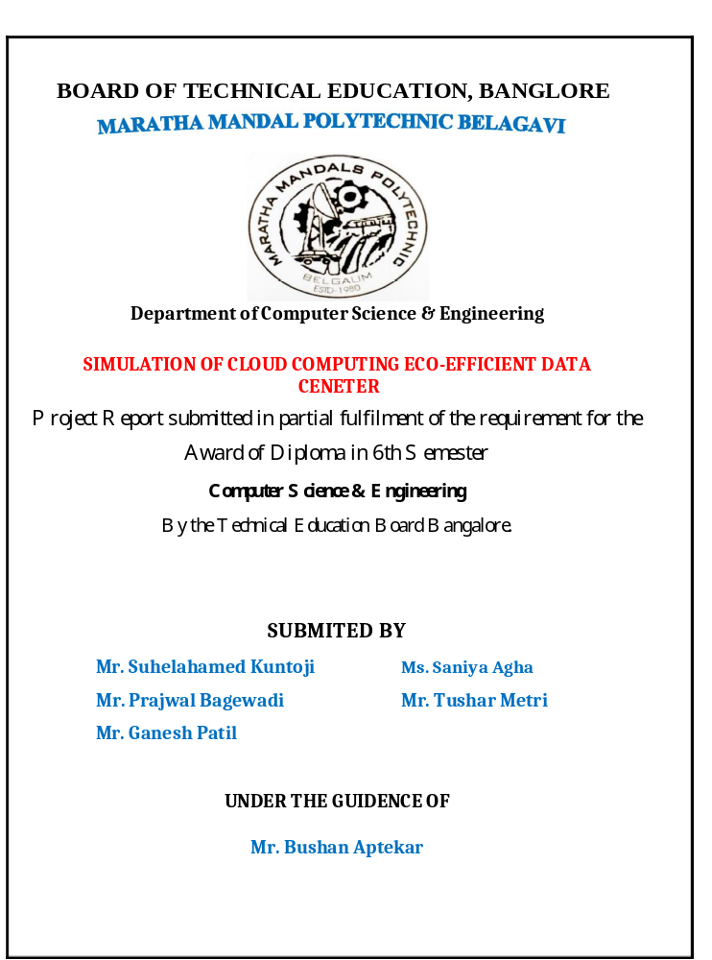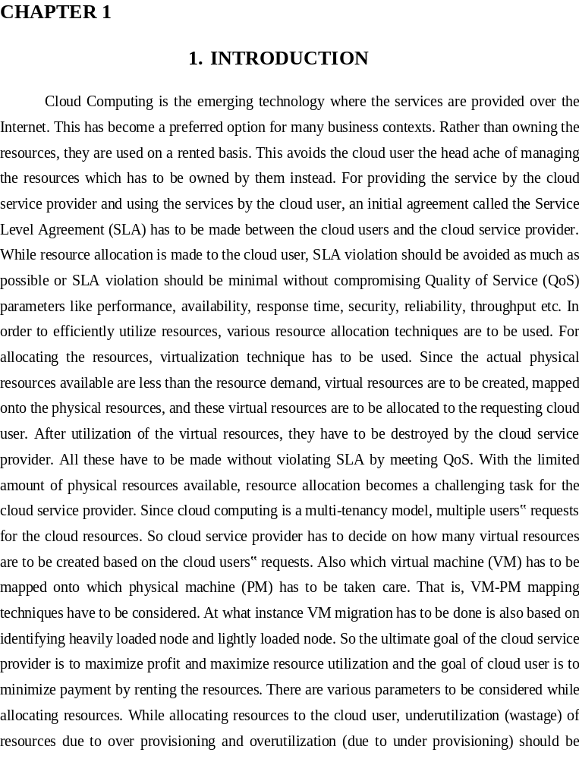

--------
ACKNOWLEDGMENT

This satisfaction that accompanies the success of any work would be incomplete without naming the people who made it possible, whose constant guidance and encouragement made this work perfect.

We wish to express our deep sense of guidance to respect Principal Shri. A. M. Potdar.

Maratha Mandal’s Polytechnic, Belagavi.

We also express our gratitude to respect HOD Shri. S. M. Patil of Computer Science Department, Maratha Mandal’s Polytechnic, Belagavi, for the benevolence they have shown towards their student.

Our cordial thanks to Lect. Bhushan Aptekar, Maratha Mandal’s Polytechnic, Belagavi, for his valuable guidance and precious suggestion. This helps us all the way to complete this research successfully.

We are thankful to our staff members of computer science Department who encouraged us during our academic year.

Finally we would like to convey heartiest thanks to all our friends, teachers and our beloved parents for their constant encourageme

ABSTRACT

Cloud service providers (CSPs) adapt different pricing models for their offered services. Some of the models are suitable for short term requirement while others may be suitable for the cloud service user’s (CSU) long term requirement. For example, reservation-based pricing model is appropriate for a CSU’s long term demand for resources. Finding the optimal amount of resources to be reserved in advance, to minimize the total cost, needs sufﬁcient research effort. Various algorithms were discussed in the last couple of years to solve the resource reservation problem but most of them are based on integer programming problem (IPP) which is NP in nature. In this paper, we derive some heuristic-based polynomial time algorithms to ﬁnd some near optimal solution to this problem. We show that the cost for CSU using our approa Cloud computing is one of the latest models used for sharing pool of resources like CPU, memory, network bandwidth, hard drive etc. over the Internet. These resources are requested by the cloud user and are used on a rented basis just like electricity, water, LPG etc. When requests are made by the cloud user, allocation has to be done by the cloud service provider. With the limited amount of resources available, resource allocation becomes a challenging task for the cloud service provider as the resources are to be virtualized and allocated. These resources can be allocated dynamically or statically based on the type of request made by the cloud user and also depending on the application. In this paper, survey on both Static and Dynamic Allocation techniques are made. Also, comparison of both static and dynamic allocatio

